**Wireframes**

**For  
 Personal Loan Mobile Application**

**Table of Contents**

1. Introduction

* Purpose
* Scope

1. Diagram Representation

* User Flow Diagram
* System Architecture Diagram

1. Wireframe Components & Key Screens

* Login Page
* Profile Page
* Loan Selection Page
* Personal Loan Page
* Loan Details Page
* EMI & Repayment Details Page

4. Wireframe Design Best Practices

5. Wireframing Tools & Technologies

6. Conclusion & Next Steps

**1. Introduction**

**Purpose**

This document provides a structured overview of the wireframes designed for the **Personal Loan Mobile Application**. It serves as a blueprint for UI/UX designers, developers, and business stakeholders to ensure alignment on the app’s functionality and user experience.

**Scope**

The wireframes focus on the **end-to-end loan journey**, including:

1. User onboarding (registration, login, and KYC verification).
2. Loan application process (eligibility check, document upload, loan approval).
3. Loan disbursement and tracking.
4. EMI management and repayments.
5. Customer support and notifications.

**Diagram Representation**

**User Flow Diagram**

A visual representation of how users navigate through the application from login to loan disbursement and EMI repayments. 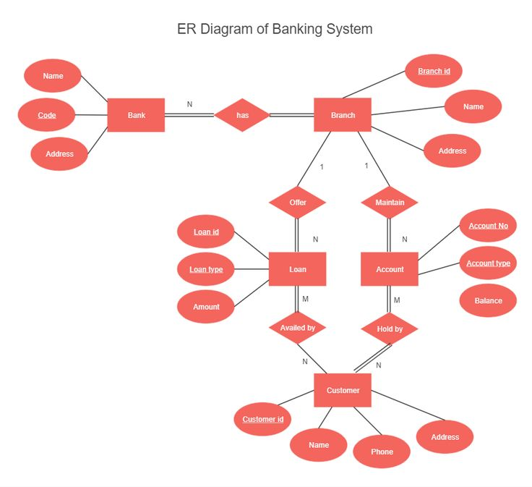

**System Architecture Diagram**

Illustrates the interaction between different system components, including front-end, back-end, database, and third-party integrations.

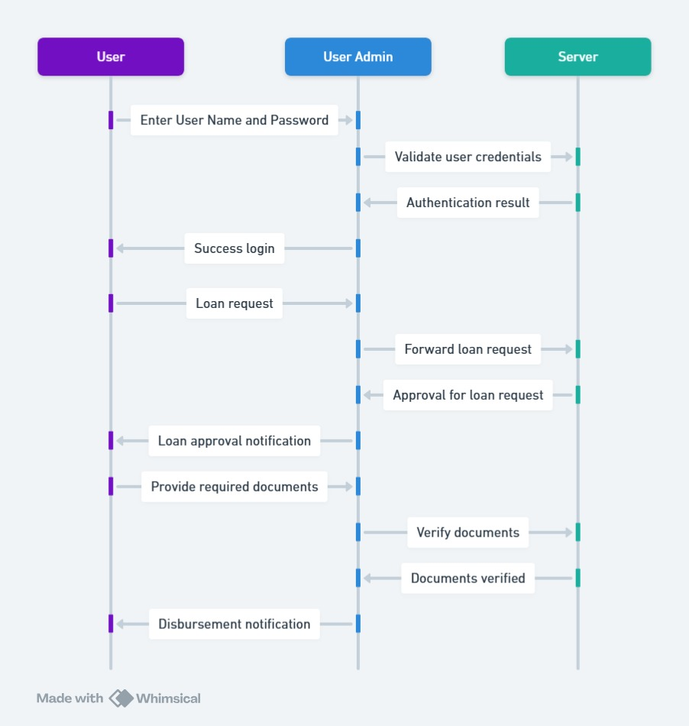

**3.Wireframe Components & Key Screens**

1. Login Page

* Fields:
  + Username
  + Password
* Actions:
  + Log In button
  + Forgot Password link
  + New User Registration

**📌 Purpose: Provides secure authentication to access the app.**

**2. Profile Page**

* Displays user full name.
* Navigation options:
  + Deposit
  + Profile
  + Loan
  + Investment
  + Insurance
  + Cards

**📌 Purpose: Acts as a central dashboard for the user’s financial activities, including loan services.**

**3. Loan Selection Page**

* Allows users to choose loan type:
  + Home Loan
  + Car Loan
  + Personal Loan
  + Gold Loan
  + Education Loan
  + Mutual Fund Loan
* Option to View Previous Loans.

**📌 Purpose: Enables users to apply for new loans or manage existing ones.**

**4. Personal Loan Page**

* Sections include:
  + Calculate EMI (for loan simulation)
  + Apply Now (start loan application)
  + Features (loan benefits & highlights)
  + Interest & Fees (loan costs)
  + Eligibility (requirements to apply)
  + Documents (KYC and financial documents upload)

**📌 Purpose: Provides all necessary details for applying for a personal loan.**

**5. Loan Details Page**

* Sections include:
  + Loan Processing & Verification (status of application)
  + Loan Sanction & Agreement (approval and digital signing)
  + Loan Disbursement (fund transfer status)
  + EMI & Repayment Details (installment breakdown)
  + Download Loan Statement (official document for records)

**📌 Purpose: Allows users to track their loan progress and manage repayments.**

**6. EMI & Repayment Details Page**

* Displays:
  + Total Loan Amount
  + EMI Due Date
  + Monthly EMI Amount
  + Loan Tenure
  + Interest Rate
* EMI Schedule Table:
  + EMI No.
  + Due Date
  + Amount
  + Status (Paid, Pending, Overdue)

**📌 Purpose: Helps users monitor their repayment schedule and pending dues.**

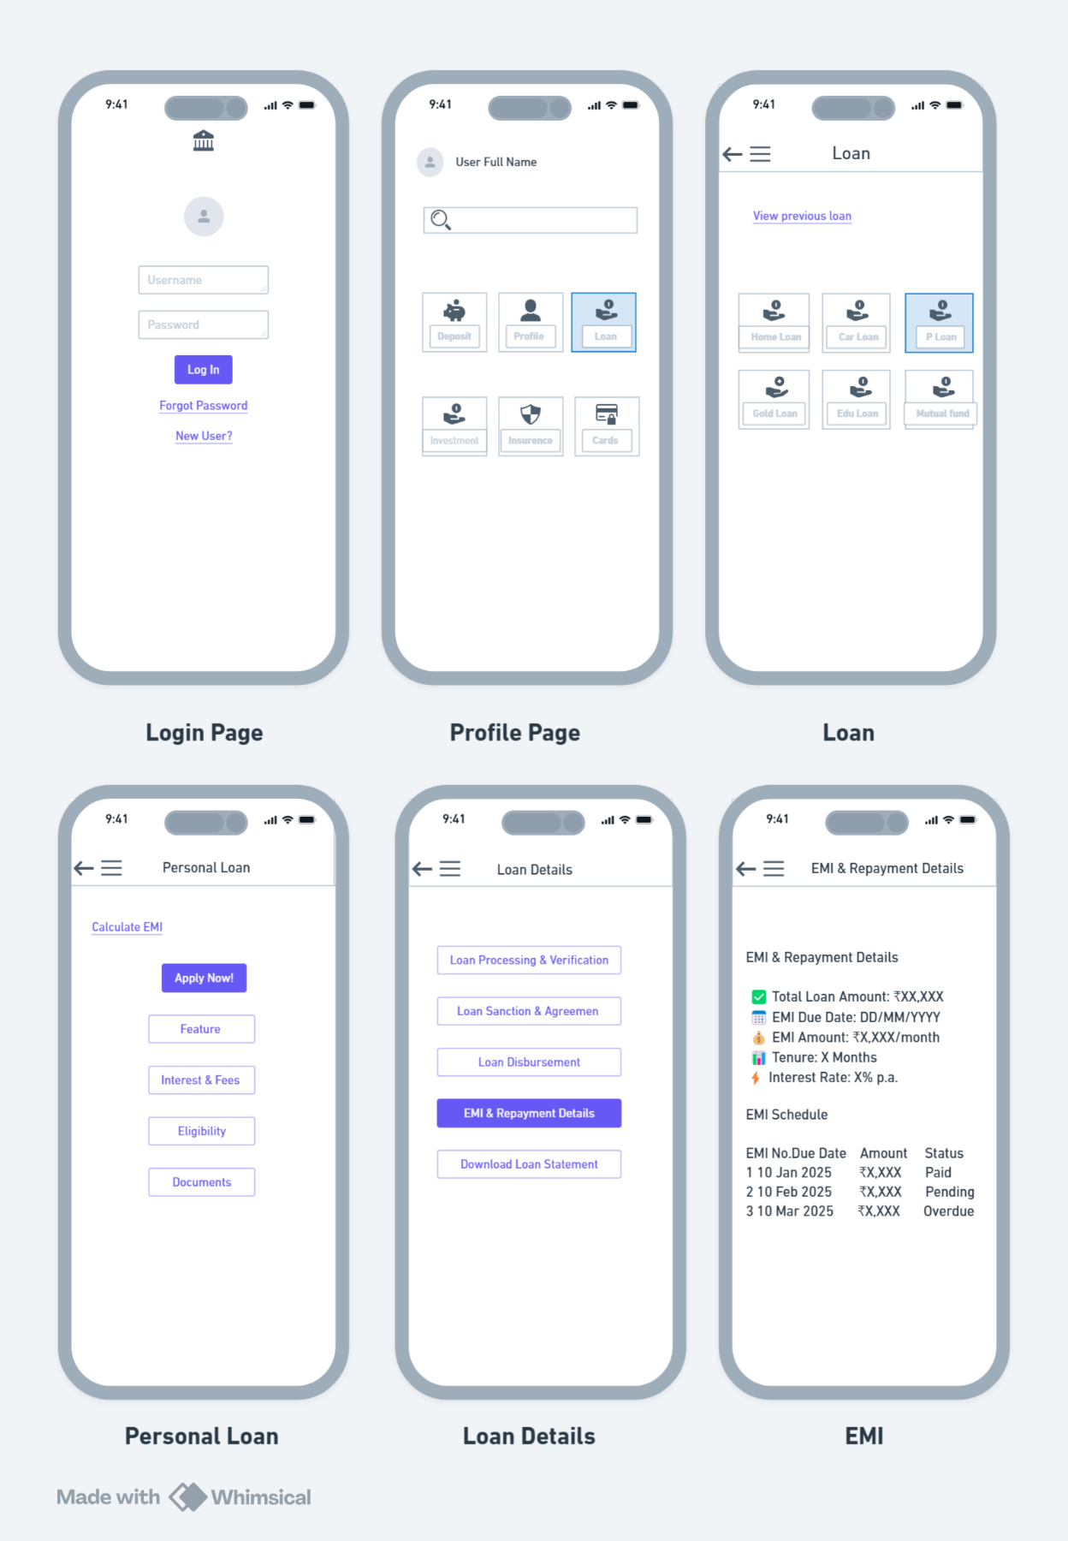

**3. Wireframe Design Best Practices**

Low-Fidelity Wireframes (Initial Sketches)

* Use grayscale wireframes to outline basic layout.
* Keep placeholder text/icons instead of final content.
* Focus on screen structure and navigation flow.

High-Fidelity Wireframes (Final Design)

* Add colors, fonts, and branding elements.
* Use real content instead of placeholder text.
* Optimize for mobile-friendly UI/UX design.

**4. Wireframing Tools & Technologies**

* **Figma:** For collaborative wireframing and prototyping.
* **Adobe XD:** For designing detailed UI components.
* **Balsamiq:** For quick low-fidelity sketches.
* **Sketch:** For creating high-fidelity UI designs.

**5. Conclusion & Next Steps**

* Finalize **wireframe review with stakeholders**.
* Conduct **usability testing on wireframes**.
* Move to **UI/UX design and development phase**.